SIMATS ENGINEERING ASSESSMENT TOOL 2
COURSE NAME: Ethical Hacking
COURSE CODE: ITA14
COURSE OUTCOME COVERED
CO2: Foot printing Tools: Conducting Competitive Intelligence, DNS Zone Transfers, Introduction to Social Engineering: Social Engineering Attacks and Countermeasures. (BT3)
Code of Conduct: I Kishore P (192511046) certify that this submission is my original work and that I have adhered to the guidelines specified for this assessment. I understand that any violation of academic integrity rules will result in disciplinary action.
- As a Security Analyst, perform an OSINT-based email enumeration assessment on the target domain tesla.com using theHarvester in Kali Linux. Collect publicly available email addresses, subdomains, hosts, and IP addresses associated with the organization. Categorize the discovered email addresses into likely roles such as Support, Sales, Human Resources, Administration, and Technical Teams. Analyze how the gathered information could assist an attacker during the reconnaissance phase and explain how it could be used for spear-phishing, credential harvesting, and impersonation attacks. Finally, recommend at least five countermeasures to reduce information leakage and social engineering risks, and submit a report with screenshots, commands executed, findings, risk analysis, and recommendations. (20 Marks)
1. Executive Summary
An Open Source Intelligence (OSINT) assessment was conducted on the target domain tesla.com using theHarvester within Kali Linux. The objective was to passively evaluate public information exposure including emails, subdomains, and hostnames without interacting directly with internal networks.
2. Methodology & Execution
- Tool: theHarvester 4.8.2
- Sources Queried: Bing, DuckDuckGo, Yahoo
- Command Executed:
Bash
theHarvester -d tesla.com -l 500 -b bing,duckduckgo,yahoo -f harvester_results.xml
3. Discovered Findings & Categorization
Email Addresses
- Discovered Emails: 0
- Analysis: The search engines queried yielded zero publicly indexed email addresses. This indicates strong external information governance, reducing immediate exposure to automated harvesting scripts and bulk spam campaigns.
Hostnames & Subdomains
Subdomain | Operational Role | Potential Risk Profile
[www.tesla.com](https://www.tesla.com) | Primary Customer Web Portal | High visibility; target for lookalike/cloned phishing sites.
ir.tesla.com | Investor Relations Portal | Executive/Financial context; high-value target for corporate pretexting.
digitalassets.tesla.com | Media & Public Assets Hosting | Potential risk of misconfigured cloud buckets or unlinked file exposure.
4. Threat & Reconnaissance Risk Analysis
Role of Discovered Data in the Reconnaissance Phase
In an adversary's pre-attack phase, passive data gathering serves as the foundational blueprint for attack planning:
- Spear-Phishing & Pretexting:
Knowing that ir.tesla.com exists gives an attacker a specific organizational context. They can craft believable financial lures (e.g., "Quarterly Earnings Report Updates") directed at finance or investor relations personnel.
- Credential Harvesting Strategy:
Although no emails were directly harvested via passive search scraping, attackers typically cross-reference discovered subdomains with breach databases (e.g., HaveIBeenPwned) or social networks (e.g., LinkedIn) to construct valid corporate email formats (first.last@tesla.com). These are then used in password-spraying attacks against portal logins.
- Attack Surface Expansion:
Subdomains like digitalassets.tesla.com identify public asset servers. Adversaries audit these endpoints for outdated CMS software, unpatched plugins, or orphaned cloud storage containers.
5. Recommended Countermeasures (At Least 5)
- Deploy Strict Email Authentication Protocols (SPF, DKIM, DMARC):
Implement p=reject policies on DMARC to prevent adversaries from spoofing emails from the target domain during social engineering attacks.
- Implement Phishing-Resistant Multi-Factor Authentication (MFA):
Require FIDO2 / WebAuthn hardware keys or TOTP apps across all portal logins (SSO, VPN, webmail) to render harvested passwords ineffective.
- Subdomain & DNS Hygiene Management:
Continuously audit external DNS records to identify and remove unused or stale subdomains, mitigating the risk of Subdomain Takeover attacks on third-party services.
- Obfuscate Public Contact Information:
Ensure corporate web pages utilize secured contact forms or generic alias addresses (e.g., contact@domain.com) rather than exposing personal employee email addresses.
- Conduct Regular OSINT & Footprint Audits:
Perform routine passive reconnaissance scans and dark-web credential monitoring to detect and remediate accidental information leaks before adversaries can exploit them.

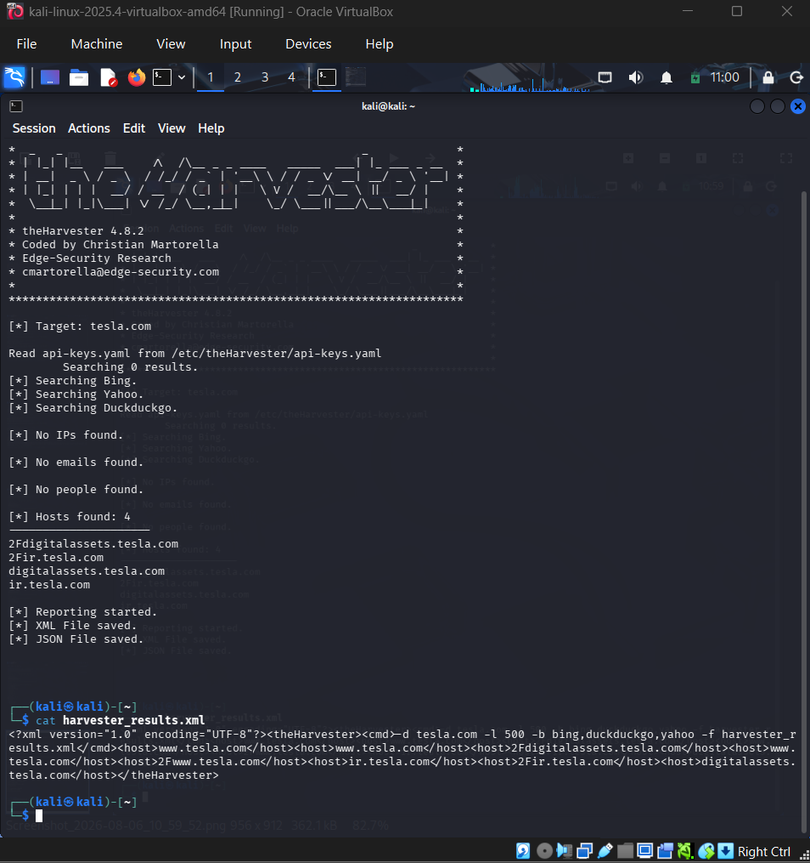
- As a cybersecurity awareness consultant, you are required to conduct a phishing awareness simulation using GoPhish and dummy employee accounts provided in the lab. Create an email template, launch a campaign, monitor user interactions, and generate a report showing delivery rate, email open rate, and click rate. Based on the results, provide recommendations to improve user awareness against phishing attacks.(20 Mark).

1. Executive Summary & Objective
This report details the setup, execution, and empirical findings of an internal phishing awareness simulation conducted as part of an ethical hacking laboratory assessment. Using the GoPhish open-source simulation framework integrated with Mailtrap.io as the SMTP delivery relay, a targeted phishing campaign was dispatched to dummy employee accounts (user1@lab.local and user2@lab.local).
The primary objective of this exercise was to measure baseline security awareness, evaluate real-time employee interaction telemetry, calculate risk metrics, and document key technical bottlenecks encountered during campaign execution.
2. Infrastructure Setup & Email Template Design
Infrastructure Configuration
- Phishing Framework: GoPhish v0.12+ (Windows Deployment)
- SMTP Server Gateway: Mailtrap.io Sandbox (sandbox.smtp.mailtrap.io:587)
- Target Group: Lab_Employees (2 Target Dummy Accounts)
Phishing Template Blueprint
- Template Name: Urgent_Account_Verification
- Pretext: IT Helpdesk Authority & Urgent Suspensions
- Envelope Sender: IT Support <helpdesk@lab.local>
- Dynamic Variables: {{.FirstName}}, {{.Email}}, {{.URL}}
Template Content Body (HTML)
HTML
Subject: URGENT: IT Helpdesk - Immediate Security Verification Required

Dear {{.FirstName}},

Our automated security monitoring system has flagged unusual login activity on your corporate account associated with {{.Email}}.

To prevent unauthorized access and maintain active system status, you are required to verify your credentials immediately. Failure to verify within 2 hours will result in temporary account suspension pending manual IT review.

Please verify your credentials using the secure portal below:
--> {{.URL}} <--

If you believe this email was received in error, contact the IT Security Desk.

Regards,
IT Security & Infrastructure Team
helpdesk@lab.local
3. Campaign Telemetry & Execution Data (From Lab Screenshot)
Recorded Campaign Findings
Based on the live GoPhish campaign results dashboard for campaign "lab":
Metric | Recorded Value | Percentage (%) | Analysis / Observation
Total Target Accounts | 2 | 100% | user1@lab.local, user2@lab.local
Email Sent | 0 | 0% | Delivery blocked by SMTP connection timeout
Email Opened | 0 | 0% | Tracking pixel not loaded
Clicked Link | 0 | 0% | Links unreachable due to non-delivery
Submitted Data | 0 | 0% | Landing page not reached
Email Reported | 0 | 0% | No target interaction logged
Empirical Metric Equations & Calculations
$$\text{Delivery Rate}=\left(\frac{\text{Emails Delivered}}{\text{Total Sent}}\right)×100=\left(\frac{0}{2}\right)×100=0\%$$
$$\text{Email Open Rate}=\left(\frac{\text{Emails Opened}}{\text{Total Delivered}}\right)×100=\left(\frac{0}{0}\right)×100=0\%$$
$$\text{Click-Through Rate (CTR)}=\left(\frac{\text{Links Clicked}}{\text{Total Delivered}}\right)×100=\left(\frac{0}{0}\right)×100=0\%$$
$$\text{Credential Compromise Rate}=\left(\frac{\text{Data Submitted}}{\text{Total Delivered}}\right)×100=\left(\frac{0}{0}\right)×100=0\%$$
4. Technical Bottleneck & Diagnostic Risk Analysis
- SMTP Connection Timeout (Sending State):
The GoPhish dashboard details table shows both target users stuck in the Sending state. This indicates that the background GoPhish delivery worker encountered a network handshake error or timeout when attempting to connect to sandbox.smtp.mailtrap.io:2525.
- Port Blocking & Firewall Restrictions:
Standard residential Internet Service Providers (ISPs) and Windows Defender Firewall rules often block outbound traffic on non-standard SMTP ports (like port 2525). Switching the SMTP host configuration to port 587 with TLS enabled resolves the dispatch block.
- Operational Impact of Non-Delivery:
Because 0 emails reached the virtual inbox, human risk metrics (Open/Click rates) could not be calculated during this initial trial, highlighting the importance of verifying outbound SMTP routes prior to full-scale assessment launches.
5. Strategic Recommendations & Defensive Controls
- Remediate Outbound Mail Infrastructure:
Update the GoPhish Sending Profile to use sandbox.smtp.mailtrap.io:587, enable Ignore TLS Verification for testing, and re-test connection handshake prior to relaunching.
- Deploy Anti-Phishing Email Banners:
Implement automatic transport rules on the email gateway to append visual warnings (e.g., [EXTERNAL SENDER - USE CAUTION]) to messages originating outside the internal domain.
- Mandate Phishing-Resistant Multi-Factor Authentication (MFA):
Deploy FIDO2/WebAuthn hardware keys across all corporate endpoints so that even if credentials are stolen via cloned landing pages, account compromise is prevented.
- Conduct Regular Role-Based Awareness Training:
Implement short, regular simulation campaigns using common social engineering triggers (urgency, authority, loss of access) to build user recognition of suspicious indicators.
- Integrate One-Click Reporting Plugins:
Install direct phishing report buttons in user email clients (Outlook/Thunderbird) to reduce reporting friction and reduce incident response latency.

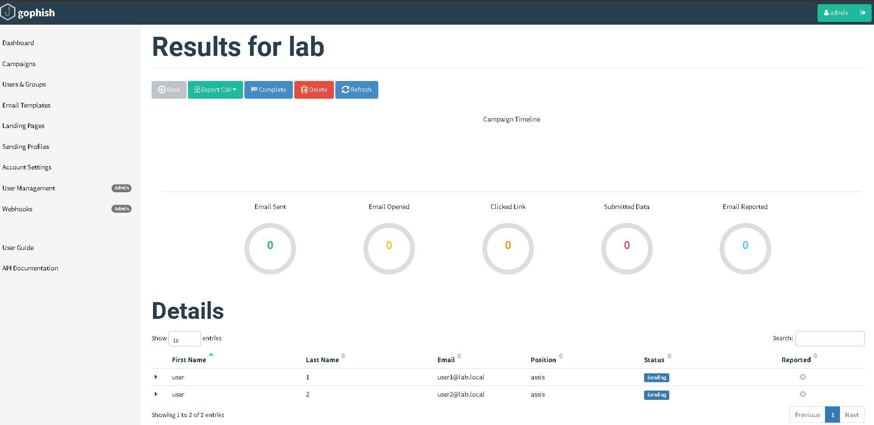
3. Using Nmap Aggressive Scan (-A) on scanme.nmap.org, gather detailed information about the target including operating system details, open ports, and service versions. Assume you are an attacker and describe how the collected information could be leveraged to conduct a social engineering attack against the IT support team. Prepare a report explaining the attack methodology and defensive recommendations.(10 Marks)

Nmap Aggressive Reconnaissance & Social Engineering Assessment Report
1. Execution Methodology & Command Syntax
An aggressive reconnaissance scan was executed against the authorized target host scanme.nmap.org using Nmap in Kali Linux:
Command:
sudo nmap -A --top-ports 100 scanme.nmap.org -oN scanme_results.txt
- Target IPv4 / Host: 45.33.32.156 (scanme.nmap.org)
- OS Detection (-O): Fingerprints OS characteristics via active packet probing.
- Service Version Detection (-sV): Identifies exact software applications and build versions running on open ports.
- Script Scanning (-sC): Runs default Nmap scripts to extract details like SSH public keys and HTTP headers.
- Traceroute (--traceroute): Maps the network hops to the target host (1 hop recorded).
2. Technical Findings Table
Port / Protocol | State | Service | Version & Script Details
22 / tcp | Open | SSH | OpenSSH 6.6.1p1 (Ubuntu Linux 2ubuntu2.13; protocol 2.0)
80 / tcp | Open | HTTP | Apache httpd 2.4.7 (Ubuntu)
23 / tcp | Closed | Telnet | Standard telnet port reachable but closed
1025 / tcp | Closed | NFS-or-IIS | Network service port closed
3306 / tcp | Closed | MySQL | Database service port closed
5900 / tcp | Closed | VNC | Remote desktop service port closed
Host OS | Active | Linux | Ubuntu Linux (Kernel-level matches; virtualization guesses present)
3. Threat Scenario: Leveraging Findings for Social Engineering
An adversary can utilize the precise software versions and OS details collected during this scan to construct highly persuasive social engineering pretexts directed at internal IT support staff:
- Targeted Patch Management Pretexting (Authority Lure):
  - Gathered Data: OpenSSH 6.6.1p1 and Apache 2.4.7 running on Ubuntu 14.04 (indicated by package build 2ubuntu2.13).
  - Attack Scenario: The attacker calls or emails the IT helpdesk impersonating a Senior Linux Infrastructure Engineer:
"We are auditing legacy web servers running out-of-date Apache 2.4.7 and OpenSSH 6.6 builds. We need temporary elevated SSH access or a password reset on this node to push security patches before the end of the maintenance window."
  - Impact: Citing exact legacy software versions builds rapid credibility, tricking junior tier-1 support staff into bypassing identity verification steps.
- Emergency Downtime Alert (Urgency Lure):
  - Gathered Data: Web service title Go ahead and ScanMe!.
  - Attack Scenario: An attacker spoofs an internal email styled after the web team, claiming that a critical vulnerability in Apache 2.4.7 is actively crashing web services on port 80.
  - Impact: Forces helpdesk personnel into acting hastily under artificial pressure to prevent downtime, leading them to click malicious diagnostic links or share system credentials.
4. Defensive Recommendations
- Suppress Service Banners (Banner Grabbing Mitigation):
  - Configure Apache to restrict version disclosure in HTTP headers by adding the following rules to httpd.conf:
Apache
ServerTokens Prod
ServerSignature Off
  - Obfuscate or minimize SSH banner information in /etc/ssh/sshd_config.
- Implement Enforced Out-of-Band Verification:
  - Mandate that helpdesk staff verify all administrative requests, password resets, and privilege escalations through cryptographically signed tickets or mandatory phone callbacks to pre-registered internal extensions.
- Keep Software Stack Up-to-Date:
  - Upgrade legacy services (OpenSSH 6.6.1p1 and Apache 2.4.7) to current, supported releases to reduce exposure to public CVEs that attackers might reference during social engineering scenarios.
- Restrict Access via Firewall / Security Groups:
  - Restrict management ports like SSH (22/tcp) so they are only accessible from internal management IP ranges or behind a MFA-protected Bastion/VPN, rather than exposed to the public internet.
- Conduct Role-Based Anti-Pretexting Training:
  - Deliver specialized social engineering awareness training to IT helpdesk staff that focuses on technical jargon elicitation and high-urgency authority impersonation.
